Extreme Temperatures: Graphing the Information

Directions: Students will complete graphs by using the data collected from the National Weather Service. Blank templates exist with and without labels. Examples are provided in the examples section.

Table of Contents
Temperature (without labels) 2
Temperature (with labels) 3
Fahrenheit 3
Celsius 4
Precipitation (without labels) 5
Precipitation (with labels in inches) 6
Winter 6
Spring 7
Summer 8
Fall 9
Example Chart and Graphs 10
Maximum Temperature 10
Average Temperature 11
Monthly Precipitation 12

Temperature (without labels)
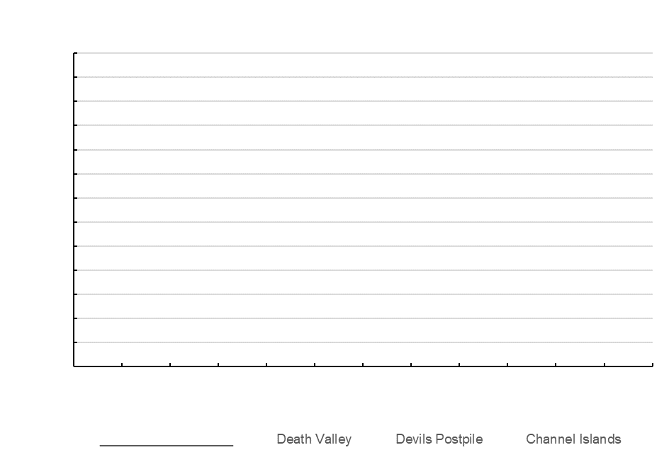

Temperature (with labels)

Fahrenheit
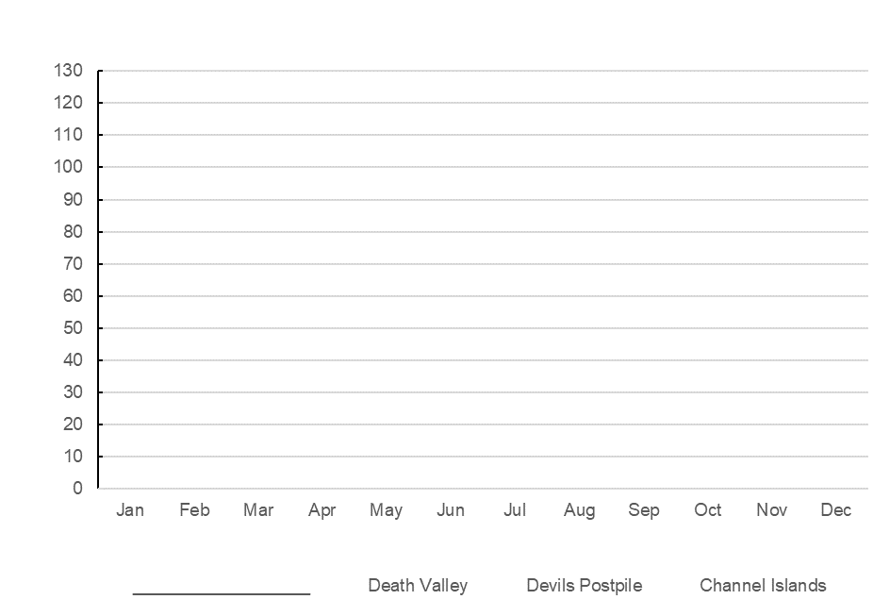

Celsius
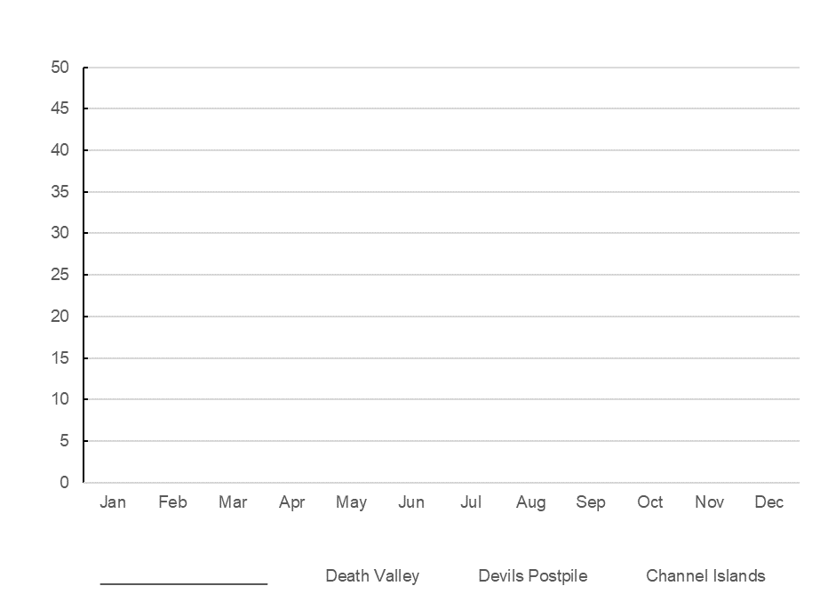

Precipitation (without labels)
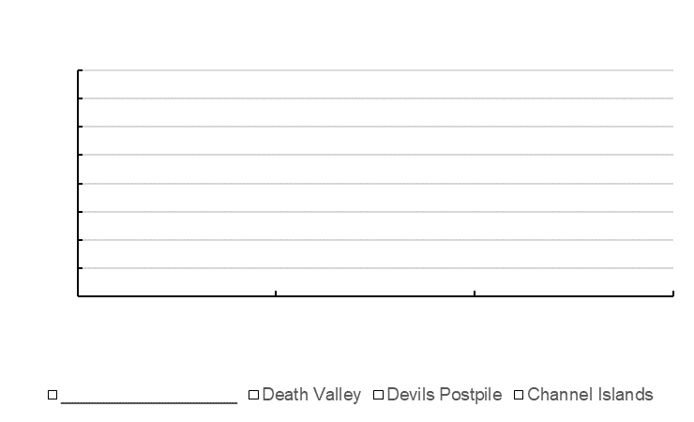

Precipitation (with labels in inches)

Winter
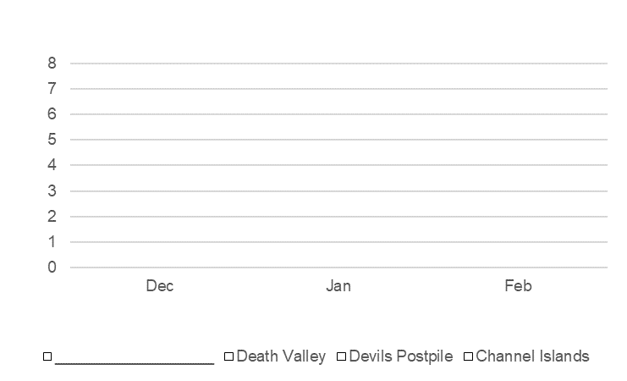

Spring
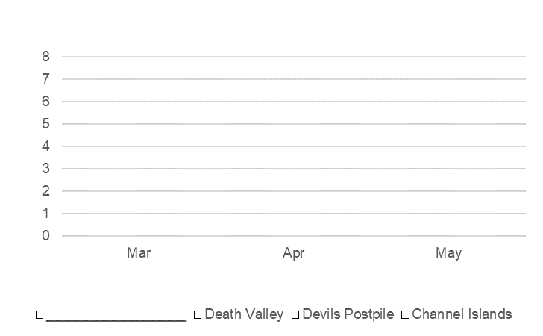

Summer
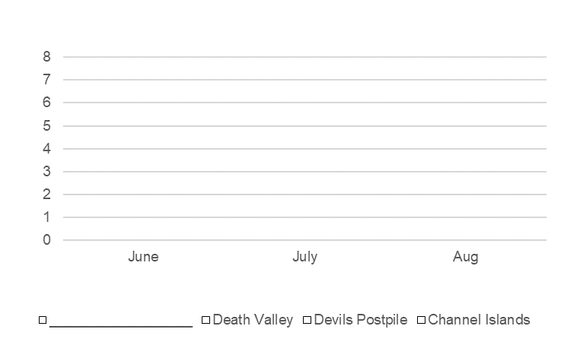

Fall
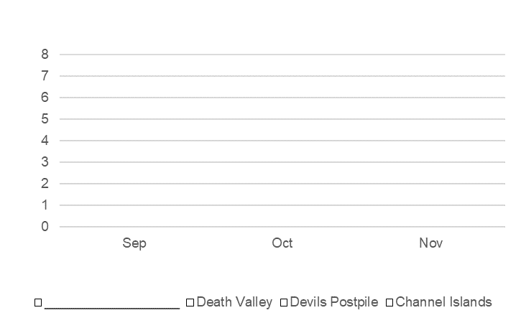

Example Chart and Graphs

Maximum Temperature
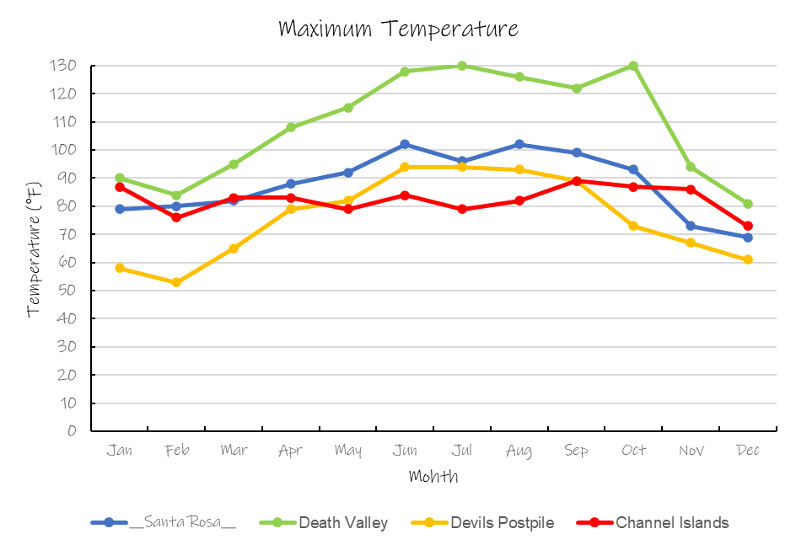

Average Temperature
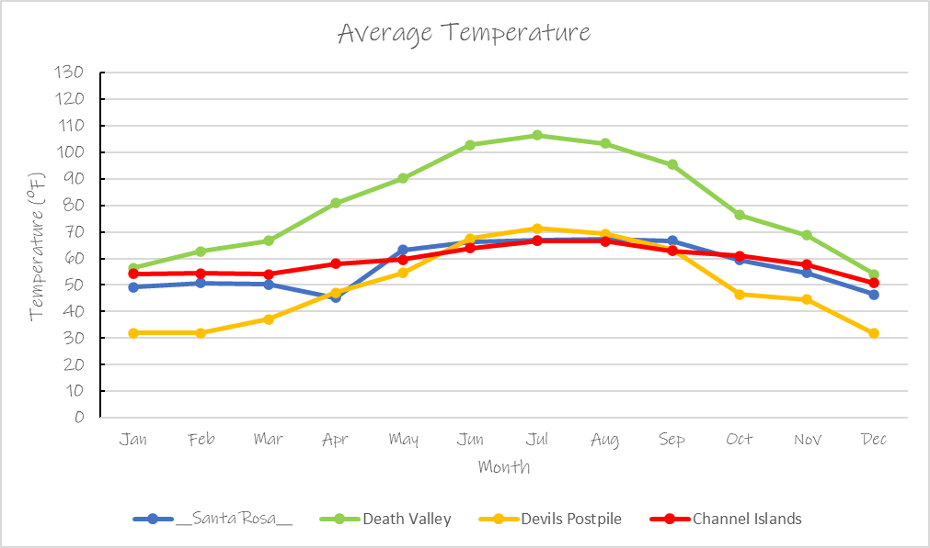

Monthly Precipitation

